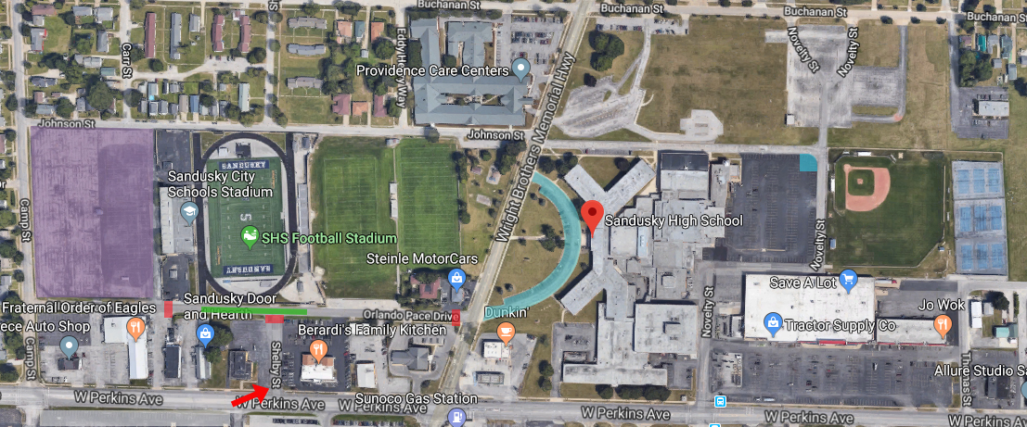

Cedar Point Stadium at Strobel Field Parking Directions
(75 Orlando Pace Drive, Sandusky, Ohio 44870)
This is an aerial view of traffic flow for Cedar Point Stadium at Strobel Field for football or soccer games.
Get off the turnpike (I-90) or Route 2 and head NORTH on Route 4 (Hayes Ave).
Turn left onto Perkins Ave.
Turn right on Camp Street, and then another right onto Orlando Pace Drive.
Parking is inside a fenced parking lot directly behind the home stands (purple area).
The red rectangles are barricades that block off Orlando Pace Drive.
The green area is for busses unloading and emergency vehicle parking only.
The light blue area is for bus parking only.
The light blue area next to Bill Deming Baseball Field is marked for Handicap Accessible Parking during baseball games.

